STAT515_Spring2021_AakashSharma_Homework2.R

AakashSharma

2021-02-10

# Import needed libraries  
library(ggplot2)  
library(tidyverse)

## ── Attaching packages ─────────────────────────────────────── tidyverse 1.3.0 ──

## ✓ tibble 3.0.6 ✓ dplyr 1.0.4  
## ✓ tidyr 1.1.2 ✓ stringr 1.4.0  
## ✓ readr 1.4.0 ✓ forcats 0.5.1  
## ✓ purrr 0.3.4

## ── Conflicts ────────────────────────────────────────── tidyverse_conflicts() ──  
## x dplyr::filter() masks stats::filter()  
## x dplyr::lag() masks stats::lag()

library(gridExtra)

##   
## Attaching package: 'gridExtra'

## The following object is masked from 'package:dplyr':  
##   
## combine

# Import source sheet that has code for the gray theme  
source("hw.R") # calls to theme_gray() and theme()  
# Reads in the counties smoking data set  
counties_smoking <- read.csv(file = "counties_smoking.csv", as.is = FALSE)  
# Reads in the states smoking data set  
states_smoking <- read.csv(file = "states_smoking.csv", as.is = FALSE)  
# Reads in the US smoking data set  
us_smoking <- read.csv(file = "US_smoking.csv", as.is = FALSE)  
  
# Reorder the regions so the legends & graphs appear in order of the region  
counties_smoking2 <- counties_smoking  
counties_smoking2$region_name <- factor(counties_smoking2$region_name,   
 levels = c('Northeast','West','Midwest','South'), ordered = TRUE)  
# Fig 1

fig1 <- ggplot(data = counties_smoking2, aes(y = region_name), fill = "grey30") +  
 geom_bar(color = "Black") +  
 labs(x = "Number of counties",  
 y = "Region",  
 title = "Figure 1. Bar chart for number of counties in each region") + hw +   
 theme(plot.caption = element_text(hjust=0))   
  
# Fig 2  
# Reorder the regions so the legends & graphs appear in order of the region  
states_smoking2 <- states_smoking  
states_smoking2$region_name <- factor(states_smoking2$region_name, c('Northeast','West','Midwest','South'))

fig2 <- ggplot(data = states_smoking2, aes(y= region_name, weight = adult_population/1000000),   
 fill = "grey30") +  
 geom_bar(color = "Black") +  
 labs(x = "Adult population millions",  
 y = "Region",  
 title = "Figure 2. Bar chart for adult population in each region") + hw +   
 theme(plot.caption = element_text(hjust=0))  
  
# Combine both fig1 and fig2 into a singular figure  
grid.arrange(fig1, fig2, nrow = 2)

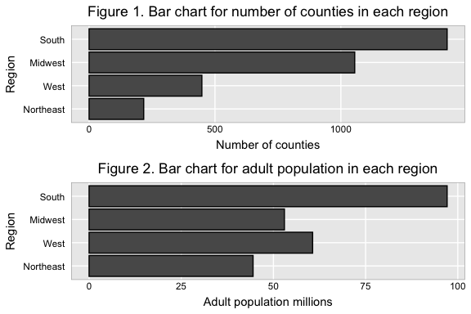

# Fig 3  
states_smoking2$pack_tax_range <- factor(states_smoking2$pack_tax_range,   
 levels = c('Less than $1.00','$1.00 - $1.99','$2.00 + '), ordered = TRUE)

vert <- ggplot(data = states_smoking2, aes(region_name, fill = fct_rev(pack_tax_range))) +  
 geom_bar(position = "dodge", color = "black") +  
 labs(y = "# states",  
 x = "Region",  
 title = paste("Figure 3. Grouped bar chart for number of states", "by region and excise tax per pack",   
 sep="\n"),  
 fill = 'Excise tax per pack') +  
 scale_fill_manual(values = c("#ab0730","#fdca44","#7d8f29"),   
 breaks = c('Less than $1.00','$1.00 - $1.99','$2.00 + ')) + hw +   
 theme(plot.caption = element_text(hjust=0))  
vert + coord_flip()

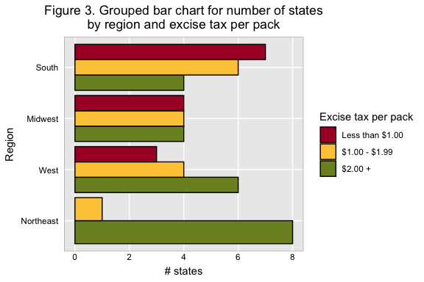

# Fig 4  
# Reorder the pack tax range so the legends & graphs appear in order of the packs  
counties_smoking2$pack_tax_range <- factor(counties_smoking2$pack_tax_range,   
 levels = c('Less than $1.00','$1.00 - $1.99','$2.00 + '), ordered = TRUE)

ggplot(data = counties_smoking2, aes(x = adult_smoking_rate, fill = pack_tax_range)) +  
 geom_histogram(binwidth = 1, color = "black") +   
 scale_fill_manual(values=c("#ab0730","#fdca44","#7d8f29")) +  
 facet_grid(rows = vars(pack_tax_range)) +  
 labs(x = "Adult smoking rate (%)",  
 y = "# counties",  
 title = paste("Figure 4. Histograms for county-level adult smoking rates", "by excise tax per pack",   
 sep="\n")) + hw +   
 theme(plot.caption = element_text(hjust=0), legend.position= "none")

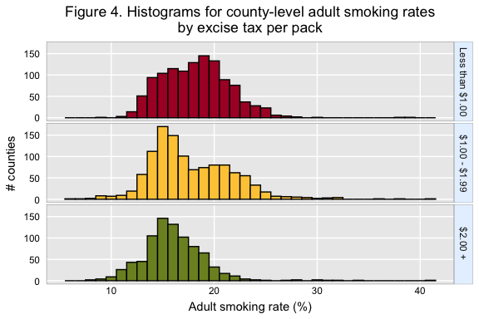

# Fig 5  
# Reorder the pack tax range so the legends & graphs appear in order of the packs  
states_smoking2$pack_tax_range <- factor(states_smoking2$pack_tax_range,   
 levels = c('Less than $1.00','$1.00 - $1.99','$2.00 + '), ordered = TRUE)  
# Create a custome colored pallette and assign the hex values  
coloredpal <- c("#ab0730","#fdca44","#7d8f29")  
set.seed(4977)

fig5 <- ggplot(data = states_smoking2, aes(x = pack_tax_range, y = adult_smoking_rate, color = pack_tax_range)) +   
 geom_boxplot(position = "dodge") +   
 geom_jitter(position = position_jitter(set.seed(4977))) +  
 labs(y = "Smoking rate (%)",  
 x = "Excise tax per pack",  
 title = "Figure 5. Box plots for state-level smoking rates") + hw +  
 theme(plot.caption = element_text(hjust=0), legend.position = "none")  
fig5 + scale_color_manual(values = coloredpal)

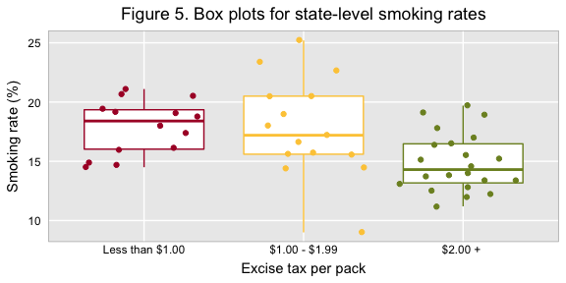

# Fig 6

ggplot(data = states_smoking2, aes(x = pack_tax_range, y = adult_smoking_rate, fill = pack_tax_range)) +  
 geom_violin() +  
 scale_fill_manual(values=c("#ab0730","#fdca44","#7d8f29")) +  
 labs(y = "Smoking rate (%)",  
 x = "Excise tax per pack",  
 title = "Figure 6. Violin plots for state-level smoking rates") + hw +   
 theme(plot.caption = element_text(hjust=0), legend.position = "none")

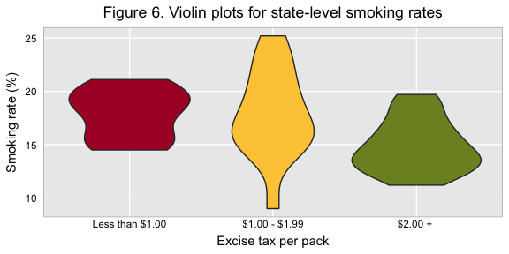

# Fig 7  
# Create the panel num for the facet  
panel_num <- c(as.integer((5:29)/5), 6L, 6 + as.integer((5:29)/5))  
  
# Before adding panel numbers to the data frame, reorder it so states w/ smallest percent   
# change are at the beginning. These states will be in the first panel.   
states_smoking_2 <- states_smoking[order(-states_smoking$adult_smoking_rate),]  
  
# Add the panel num variable to our new states smoking dataframe  
states_smoking_2$panel_num <- panel_num  
  
# Because states are a factor, ggplot() will put the states names along the y axis in   
# increasing level order starting at the BOTTOM of the graph. Need to reorder the factor levels  
# of states, so states w/ the largest changes have the lowest level numbers  
states_smoking_2$state <- reorder(states_smoking_2$state, states_smoking_2$adult_smoking_rate)  
  
# Must factor the pack tax range for the fill  
states_smoking_2$pack_tax_range <- factor(states_smoking_2$pack_tax_range,   
 levels = c('Less than $1.00','$1.00 - $1.99','$2.00 + '), ordered = TRUE)

ggplot(data = states_smoking_2, aes(x = adult_smoking_rate, y = state, fill = pack_tax_range)) +   
 geom_point(shape = 21, size = 2) +  
 scale_fill_manual(values = c("#ab0730","#fdca44","#7d8f29")) +  
 scale_x_continuous(breaks = seq(10, 26, by = 2)) +   
 labs(x ="Percent smoking (%)",   
 y = "State",  
 title = paste("Figure 7. Row-labeled plot for", "state-level smoking rates",   
 sep="\n"),  
 fill = 'Excise tax per pack ($)') + hw + guides(fill = guide_legend(reverse = FALSE)) +  
 facet_grid(vars(panel_num), space = "free", scales = "free") +  
 theme(strip.text=element_blank())

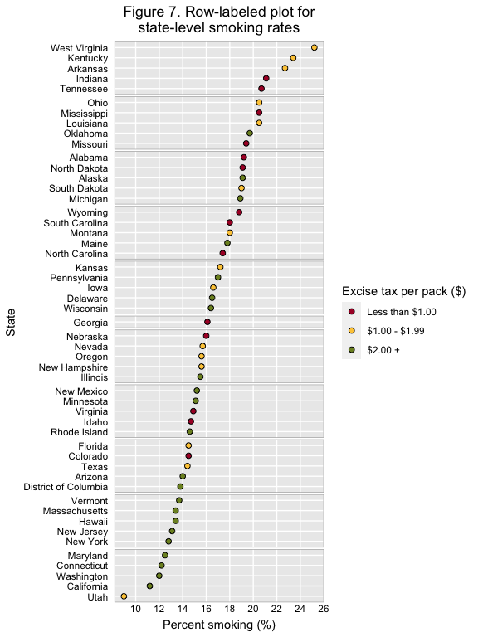

# Fig 8

ggplot(data = us_smoking, aes(x = year)) +   
 geom_line(aes(y = male_smokers), color = "#19a0aa") +   
 geom_line(aes(y = female_smokers), color = "#f15f36") +  
 scale_x_continuous(breaks= seq(1996, 2016, by = 2)) +   
 scale_y_continuous(breaks= seq(16, 24, by = 4)) +   
 geom_text(aes(x = 2016, y = 18.5, label = "Men")) +   
 geom_text(aes(x = 2015.75, y = 14.5, label = "Women")) +  
 labs(x = "Year",  
 y = "Smoking rate (%)",  
 title = "Figure 8. Line graph for US adult smoking rates (1995-2017)",  
 caption = paste("Source: National Health Interview Survey (NHIS).",   
 "In 2006, the NHIS implemented a new simple design.",   
 sep="\n")) + hw +  
 theme(plot.caption = element_text(hjust=0), legend.position = "none")

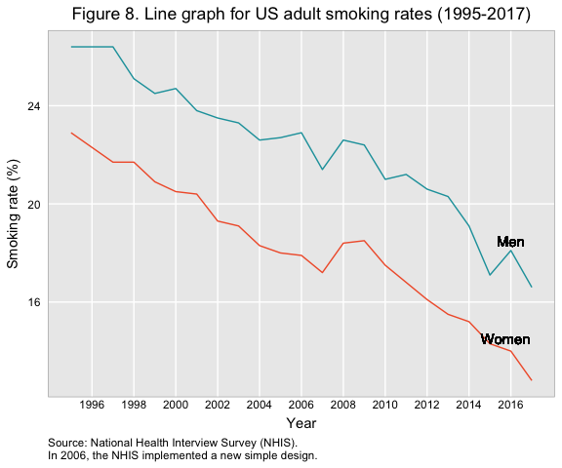

# Clean Up, reset memory as well clear our env pane  
rm(list=ls())  
gc(verbose = TRUE, reset = TRUE)

## used (Mb) gc trigger (Mb) max used (Mb)  
## Ncells 1177487 62.9 2115560 113 1177487 62.9  
## Vcells 2070013 15.8 8388608 64 2070013 15.8

format(memory.size(), units = "MB")

## Warning: 'memory.size()' is Windows-specific

## [1] "Inf"